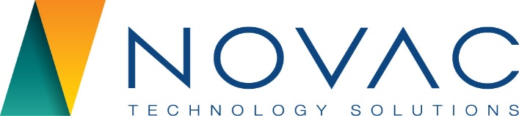

NOVAC TECHNOLOGY SOLUTIONS

User Manual

Document Version No.: 1.00

Revision History
Version No | Reason For Changes | Author | Approver
0.01 | Draft | Anurag Kumar
1.00 | Reviewed & Approved the User Manual | Anurag Kumar | NIJANTHAN PL

Table of Contents
1. Introduction 4
2. Combined Payment report 4

Introduction

The document is prepared to understand the reports generated in ZIVA application for all products. This document is being prepared in reference to:
- Guidelines, circulars, instructions and directions released from time to time by Philippines Insurance council.

Combined Payment report
System should have the provision to generate the Combined Payment Report based on the input parameters. System should generate the report in “.xls” format and this report should map under the MIS report menu.

Path: Report -> Mis Report
Screen Code: 158

- Select the Mis Report from the main menu
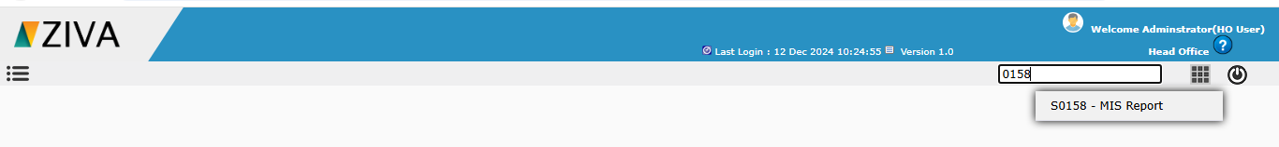

- Click on Mis report

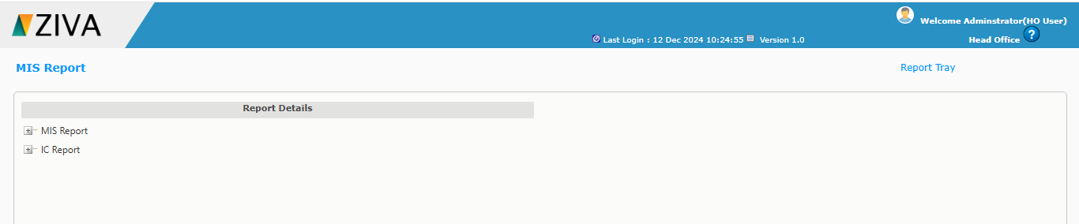

- Click on Add button in Mis Report and then click on Combined Payment report.

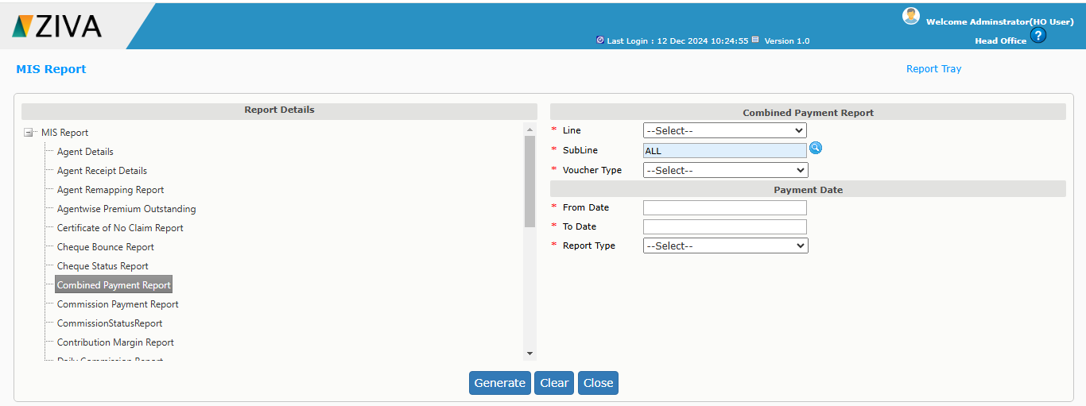

- Enter all the mandatory details and click on generate button. System will display an alert message as “Report is being generated. You may now close this window. Go through Reports Tray to view the Report”

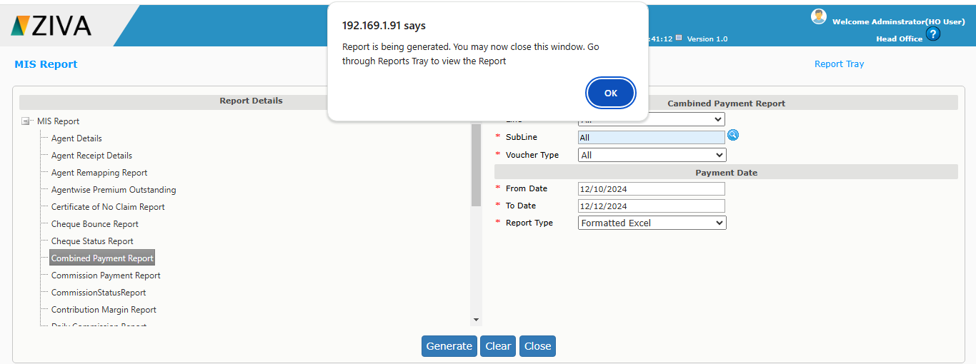

- User can download the report from the report tray.

